**EXPERIMENT NO: 4**

**AIM:** Write python program for inserting an element binary search tree.

**NAME:** Nishant Bhandari

**CLASS: SYCS**

**ROLL NO :**06

**SUBJECT: FA**

**SIGN:**

**Source code:**

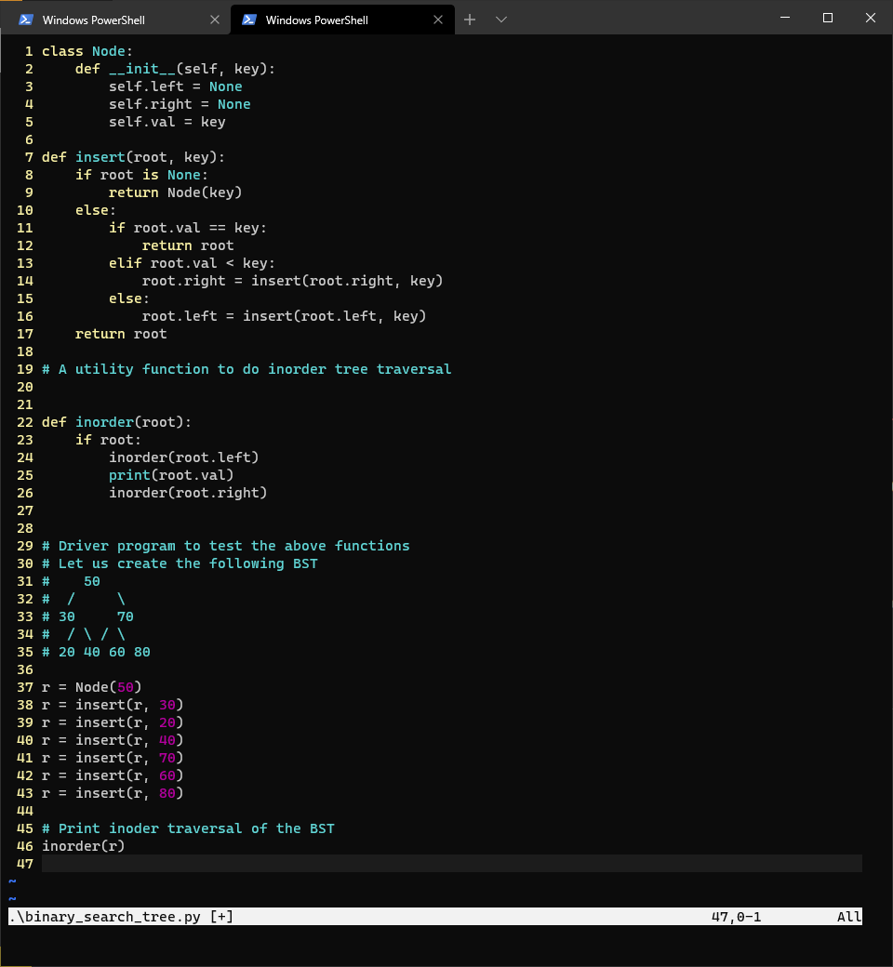

**Output:**

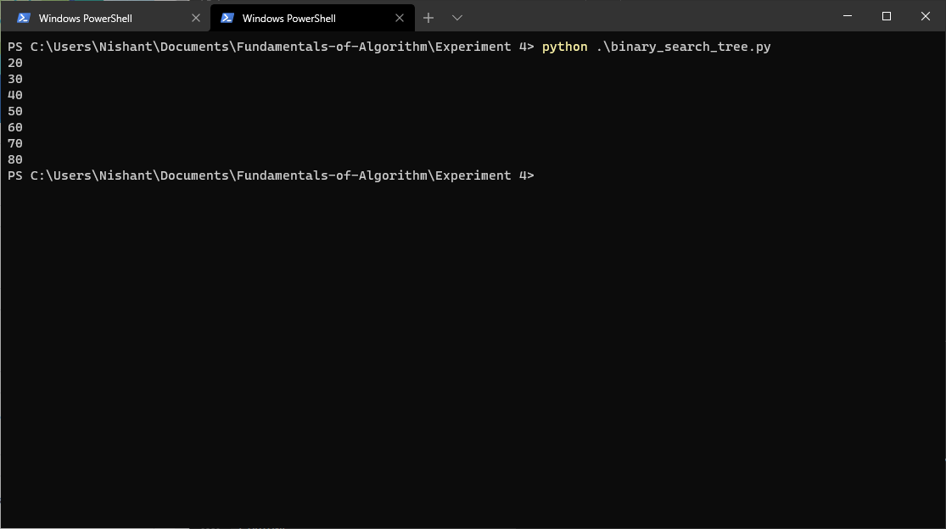

**Conclusion:** Thus, we have studied about Write python program for inserting an element binary search tree